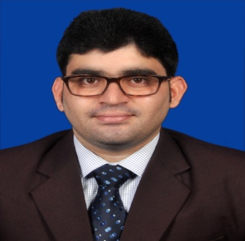
BISWANATH PANDA
Mob: 09986051006
E-mail: biswanathpanda93@gmail.com

CAREER OBJECTIVE
Seeking a career in the field of Human Capital where I can utilize my skills and abilities to gain expertise for achieving Organizational and personal growth and prosperity.
INTEREST AREA:
- Hr Recruiter
- Management Trainee
- Hr Generalist

EDUCATIONAL QUALIFICATION

2014-2016: Completed Master of Business Administration (MBA) with HR and Marketing as specialization papers at Astha School of Management, Bhubaneswar being affiliated to Biju Pattnaik (BPUT), Odisha and Approved by All India Council of Technology for Education (AICTE), New Delhi.
2011-2014: Completed Bachelor of Business Administration (BBA) from Arya School of Management and Technology, Bhubaneswar under Utkal University odisha.
2009-2011: Completed +2 (ARTS) from Sarba Mangala Maha Vidyalaya, Golamunda under Council of Higher Education (CHSE), Odisha.
2008-2009: Completed 10th from Govt High School Golamunda, Under Board of Secondary Education (BSE) Odisha.

EXPERENTIAL LEARNING
Summer Internship Program (SIP):
- Project Title: Contract Labour Management at T.S. ALLOYS Limited.
- Duration: 2 Months
- Task Handling: Grievances, Documentation, Wages Part
LIVE PROJECT:
- Customer awareness about educational sector in Bhubaneswar in November 2014
- Customer satisfaction about services provided at Nandankanan in August 2014
TECHNICAL PROFICIENCY
PGDCA
SKILLS
- Motivational skill
- Conflict handling skill
- Communication skill
ACHIEVEMENTS
- I got 1st prize in science exhibition in school level.
- I got 2nd prize in debate competition in school level.

CERTIFICATION COURSES:
Successfully Completed in 2 days program on Digital Marketing in Indian Institute Of Management Calcutta.

PERSONAL DETAILS

- Father Name : Sri Bishnu Charan Panda
- Mother Name : Smt Rashmi Panda
- Contact Details : AT- Tumura, PO- Manjhari, PS- Golamunda
VIA- Dharamgarh, DIST- Kalahandi (Odisha)
PIN- 766015
- DOB : 04th August 1993
- Linguistics Proficiency : English, Hindi, Odia
- Hobbies : Playing Badminton, Reading magazine, Cooking
- Strength : Hardworking, Self Confidence

DECLARATION
I hereby declare that all the information furnished above is true to the best of my knowledge.

DATE-
PLACE-

Signature

